Name : Rochak Chhetri
Student ID : 12323983

e-portfolio - Intellectual Property
A collection of artefacts that demonstrate what I have learnt about Intellectual Property this week

Workshop attendance
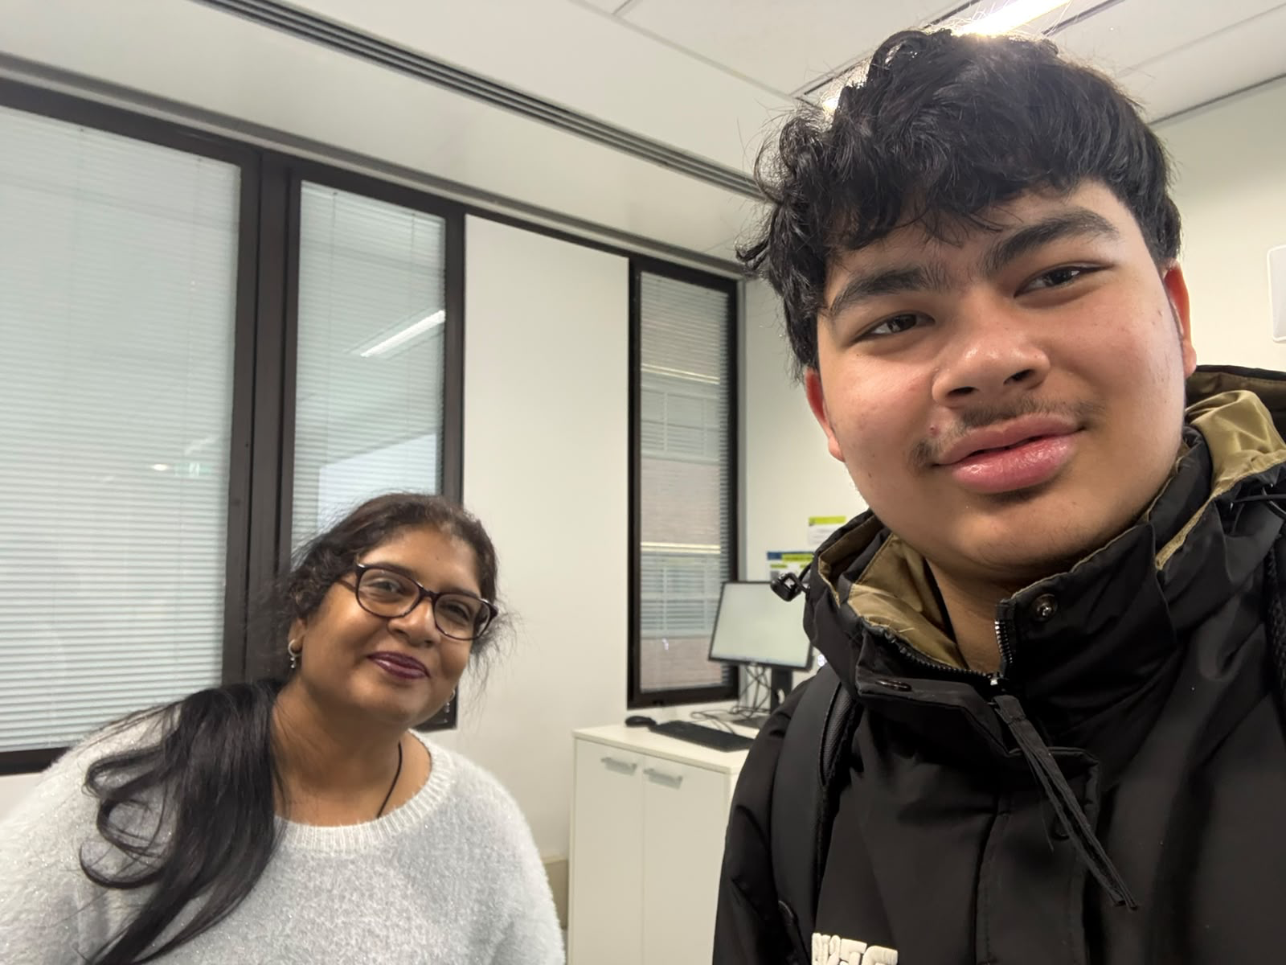Figure 1: Selfie taken during the Week 7 workshop on Intellectual Property.

Artefact 1: Software & Apps – Australian Copyright Council Fact Sheet
How copyright law applies to people who develop desktop software, mobile apps, games and web applications
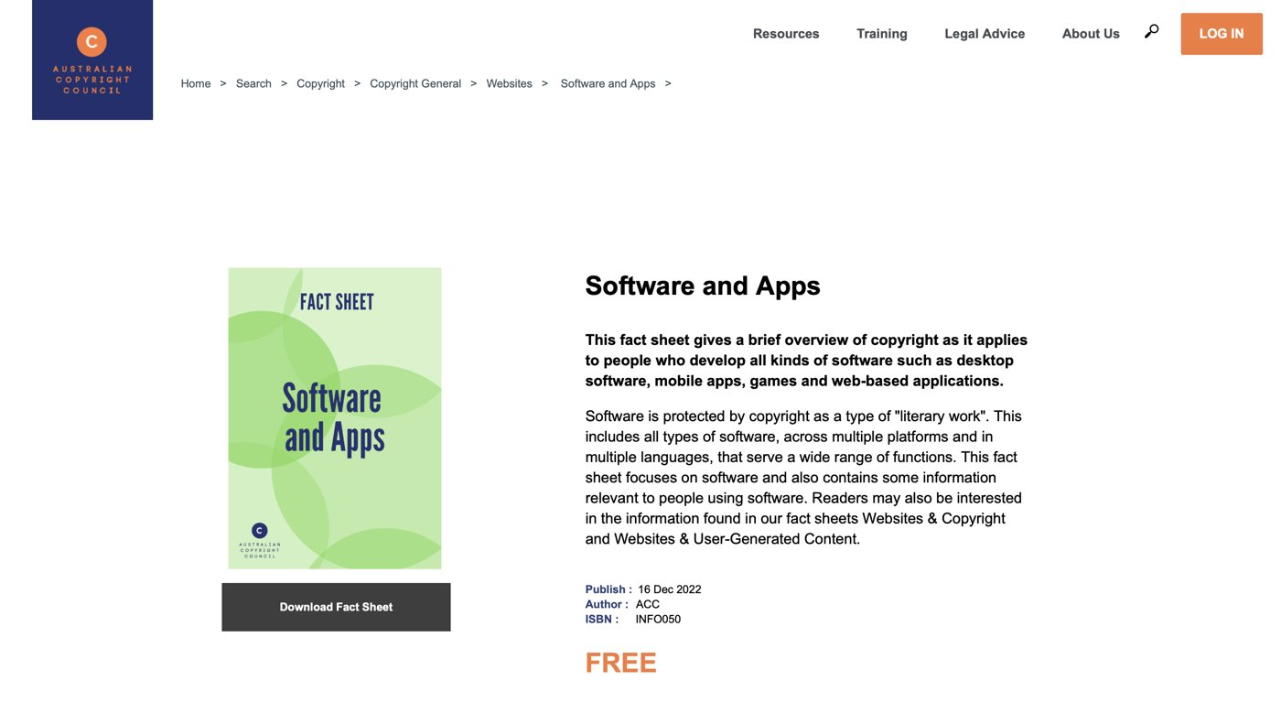
Figure 2: Australian Copyright Council Fact Sheet G050 v14, Software & Apps (December 2022).

Summary of the artefact

According to the factsheet by the Australian Copyright Council, the category under which software falls is “literary works,” along with literary works such as novels and poems. What is more important, it is pointed out that copyright in Australia is automatic and it is not necessary to register software in order to get copyright. However, it is important to bear in mind that copyright protects the specific way the code is written but not its ideas, functions or data – in other words, two different people may develop programs performing the exact same functions without infringing one another’s copyright. In addition, it is also important to remember that the issue of who owns the copyright is dependent on whether or not the person who developed the code was an employee at the time of its development as it is the employer who owns the copyright. In addition, it is mentioned that purchasing software implies purchasing the license only, not the right to duplicate it for personal use, as Australia does not have an exception allowing it.

Justification on why I chose the artefact

The fact sheet chosen by me is the one issued officially in Australia for people such as myself who will be working on software in a professional capacity. What was most surprising in this fact sheet was the problem of employer ownership, which implies that as an employee, I would not automatically possess any copyright of my software code which I will write during my time at work despite the fact that I will be writing the lines of my own code. The fact sheet has a direct correlation with slides 5 and 38-40 of the Week 7 Workshop which deal with software copyright, licensing, and End User License Agreements (EULAs). One of the main limitations of this fact sheet is that it was released in December 2022 without any reference to AI generated code or models based on publicly available code repositories.

Artefact 2: Fully AI-generated music to be banned from ARIA charts
ARIA updates its Charts Code of Practice to exclude music created wholly or mostly by artificial intelligence
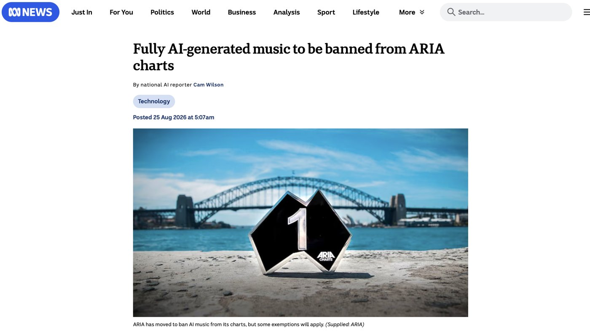
Figure 3: ABC News, 25 August 2026 - ARIA bans fully AI-generated music from its charts.

Summary of the artefact

As per the news, ARIA has changed its Charts Code of Practice, making sure that music that is created exclusively or primarily with the aid of artificial intelligence does not appear in the charts of ARIA. Nonetheless, those songs created with the help of AI but are "substantially human-made" can be eligible, as the move applies to the songs that are exclusively created through artificial intelligence and does not apply to the ones that have used AI technology in creation. This move was taken against the song created in the cover of Madonna by a Queensland DJ who got into the number four place in two ARIA charts in July 2026, presumed to be an AI creation. As per Annabelle Herd, the CEO of ARIA, this move will give people who release music in Australia a clear guide, while IFPI has other concerns regarding the training of AI on musicians' music.

Justification on why I chose the artefact
This is the newest artifact in my portfolio, created in August 2026, and is relevant as it shows how industry organizations are reacting to the development of AI nowadays as opposed to how the existing legislation has defined it until now. The “substantially human-made” standard created by ARIA is essentially the same human authorship test that was accepted in the monkey selfie case (Artifact 4). What happens in this case is that a threshold is set depending on the degree of human or non-human creativity. In my view, it is important to emphasize that ARIA as an industry organization has accepted this standard as the legislation does not provide for this case yet – although this is beneficial for the artists now, it may become inconsistent later as each industry organization will establish its own standard. The accusation of musicians in that AI models learned from their art without their consent is the same complaint as software developers have regarding code generation models.

Artefact 3: Copyright law in the age of AI - AI-generated works and copyright challenges in Australia
Peer-reviewed analysis of how Australian copyright law handles works generated by artificial intelligence
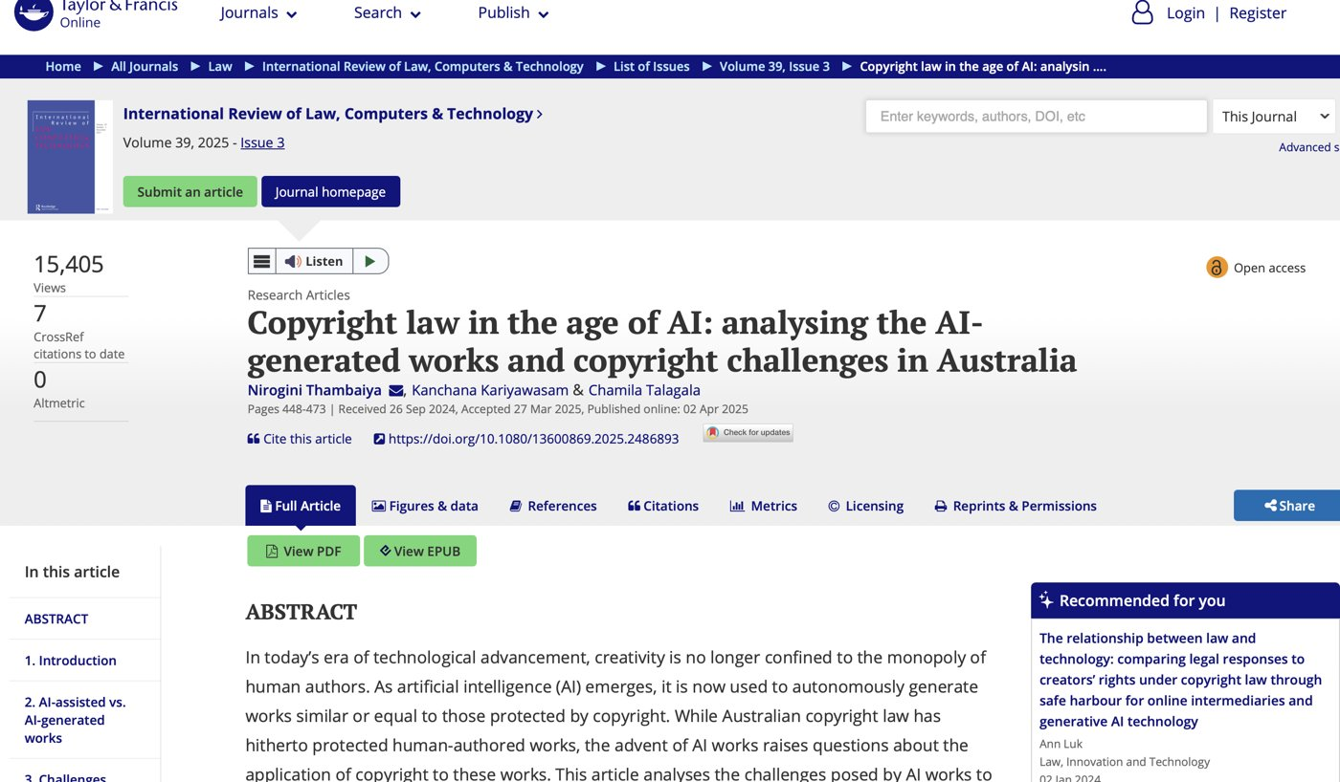
Figure 4: Thambaiya, Kariyawasam & Talagala (2025), International Review of Law, Computers & Technology, vol. 39, no. 3.

Summary of the artefact
This is a research article published in 2025 in the International Review of Law, Computers & Technology Journal. The aim of this research paper is to determine whether there is any work that will be copyrighted using the copyright act of 1968 (Cth). This is due to the fact that the work has been created through the use of AI technology. This research paper has been written by academics from Griffith University and Charles Darwin University in Australia on the issue of copyright of AI generated work from the Australian perspective. As per the conclusion reached by the academics, AI generated work cannot be copyrighted.

Justification on why I chose the artefact
Peer-reviewed literature was included in order to provide a more thorough discussion of the legal aspects of the problem because the academic sources discuss the problem in a much more detailed manner than the journalistic sources do since they analyze rather than just describe an event. This source provides another perspective on the problem – it is an academic perspective on the problem just like the other sources discussed – the software (Artifact 1), music (Artifact 2), and photography (Artifact 4) oppose the notion of human authorship. It is evident now what was mentioned on slide 11 of the workshop – such organizations as Arts Law consider the legal status of the work produced by the AI ambiguous. For the ICT specialists, it means that if there is no owner of the copyright of the code generated by the AI, it will be impossible to prevent the competitors from using the same code.

Artefact 4: The Monkey Selfie Copyright Dispute (key idea from Workshop 7)
Naruto v Slater (2011-2018) - can a photograph taken by a macaque be owned by anyone?
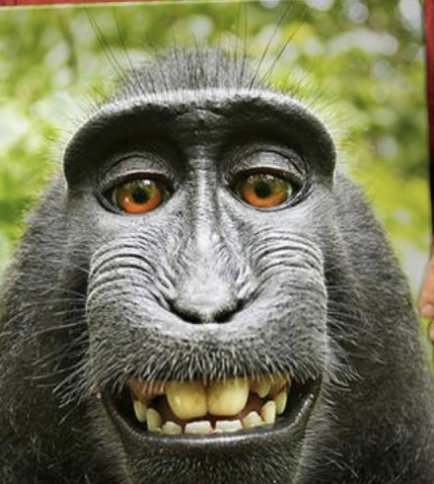
Figure 5: The monkey selfie taken by Naruto, a crested macaque, using David Slater's camera.

Summary of the artefact

This case involves photographs taken by David when he was photographing a crested macaque in Sulawesi and the monkey Naruto pressed the button. As per Wikipedia, the photographs are in the public domain as the copyright requires a human author. However, the defendant contends that the photographs were copyrighted by him since he gathered everything needed for taking the photographs. PETA sued the defendant on the monkey's behalf in 2015, and the court ruled that animals could not claim copyright in the United States. It should be noted that the case ended in settlement where the defendant donated future profits from the photos to charity.

Justification on why I chose the artefact
This is the required workshop artefact and it is taken from slide 2 of the Week 7 Workshop Intellectual Property. From slide 10, the students were asked the question, “Who owns images created by AI?” – based on this example, my interpretation of the situation is that nobody owns these images, since there is no author of the work (human) which is a requirement for copyright protection, neither animal (nor AI machine). This topic is discussed extensively in this portfolio: 2018 monkey selfie case established the fact that there should be a human author for the copyright protection; in 2022 Copyright Council of Australia Fact Sheet, the programmer (still human) is considered an author; in ARIA's 2026 test of “substantially human-made,” the same idea applies, however, for music. Taking into consideration all four artefacts above, it can be concluded that the law does not move forward in line with technology but is being fixed patch by patch. Being a future ICT professional, it is obvious that it is important to know how the copyright law protects the products made with the help of AI.

References
Australian Copyright Council 2022, Software & apps, fact sheet G050 v14, Australian Copyright Council, Sydney, viewed 6 September 2026, https://www.copyright.org.au/
Galea, G 2026, COIT11223 ICT ethics and governance in society: week 7 workshop - intellectual property, PowerPoint slides, CQUniversity, Rockhampton.
Guadamuz, A 2018, 'Can the monkey selfie case teach us anything about copyright law?', WIPO Magazine, 21 February 2018, viewed 6 September 2026, https://www.wipo.int/en/web/wipo-magazine/articles/can-the-monkey-selfie-case-teach-us-anything-about-copyright-law-40287
Quinn, MJ 2020, Ethics for the information age, 8th edn, Pearson, United States.
Thambaiya, N, Kariyawasam, K & Talagala, C 2025, 'Copyright law in the age of AI: analysing the AI-generated works and copyright challenges in Australia', International Review of Law, Computers & Technology, vol. 39, no. 3, pp. 448-473, viewed 6 September 2026, https://doi.org/10.1080/13600869.2025.2486893
Wilson, C 2026, 'Fully AI-generated music to be banned from ARIA charts', ABC News, 25 August 2026, viewed 6 September 2026, https://www.abc.net.au/news/2026-08-25/ai-generated-music-to-be-banned-from-aria-charts/107072642

